PRSONAL LETTER

Personal letter adalah surat pribadi yang ditulis untuk orang yang sudah kita kenal seperti orang tua , saudara, teman. Surat ditulis tidak hanya untuk menyampaikan informasi tapi juga untuk mengeratkan persaudaraan atau pertemanan.

Bagian surat pribadi:

1. The Heading ( tulis alamat, tanggal)
2. The greeting ( kalimat salam )
3. The body ( isi surat )
4. The complimentary close (kalimat penutup surat)
5. The signature line (tanda tangan)
6. Postcript ( tulis P.S. jika ada)

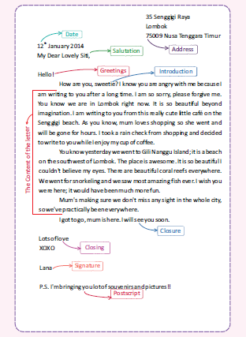

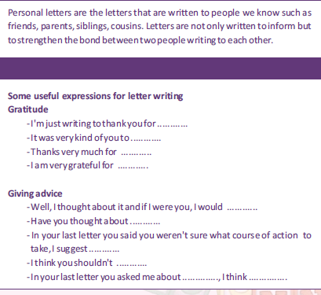

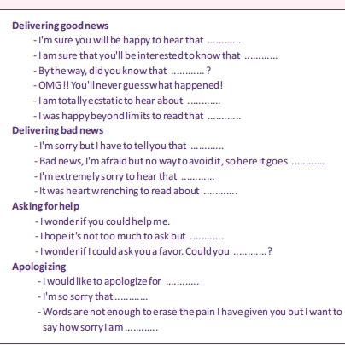

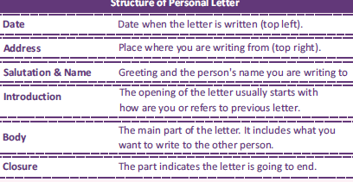

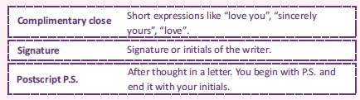

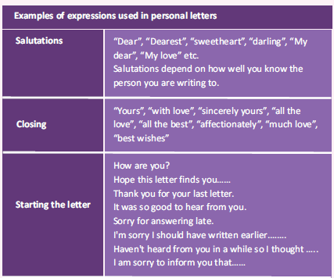

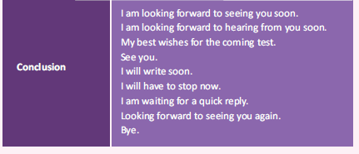

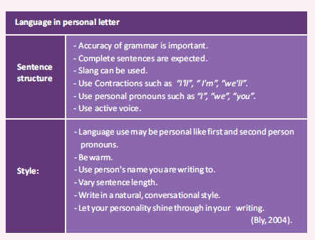

Attention: parents of SMK Erlangga Students

The principal of SMK Erlangga

Invites you to attend the annual parent meeting 2017-2018

What : Parent advisory Commite

When : Saturday, April 15TH ,2017 at 10,00-11.30 a.m.

Where : Padma Student Hall. Jl Panglima Sudirman no 27, Semarang

Learn, listen, ask questions and tell us your ideas

RSVP

Contoh balasan undangan bisa hadir

|  |
| --- |
| RSVP Card  Name : Suryana  Telephone: 082322897654  Accept : v  Regret :  Number of person attending: 1 |

2.

You are invite to Farah’s

13TH Birthday Party

Sunday , September 24TH .2018

11.00 a.m.

Jl Semeru 15, Banjarmasin

Regret only :

18155512345

Be there ! We will have Fun!

.

Contoh balasan undangan tidak dapat hadir

|  |
| --- |
| Dear Farah.  Thank you for your birthday invitation, unfortunately, I have singing audition on the same day and therefore I won’t be able to come to your party. I wish I could attend |

3.

Wedding Invitation

Together with their families,

Melati Tobing

And

Ronny Simanjuntak

Invite you to celebrate their marriage.

Sunday, October 8TH ,2017

At six o’clock in the evening

Nirvana Ballroom-Fairmont Hotel

Jl Asia Aprika 8, Jakarta

Dinner and dancing to follow

rsvp

Contoh balasan undangan bisa hadir

|  |
| --- |
| Mr. and Mrs William Brown thank the bride and groom for their kind invitation for Sunday,October 8Th , which they have the honor to accept.  Besh wishes  Julia Brown |

Bambang and Susi are having a barbeque, Join us!

Saturday, August 28TH ,2017

From 6 p.m onwards At Citra Land III/21 Surabaya

BYO drink and meat for the barbeque;

Your own meat, your own taste!

(We will have some extras, along with heaps of salads)

Be there

4.